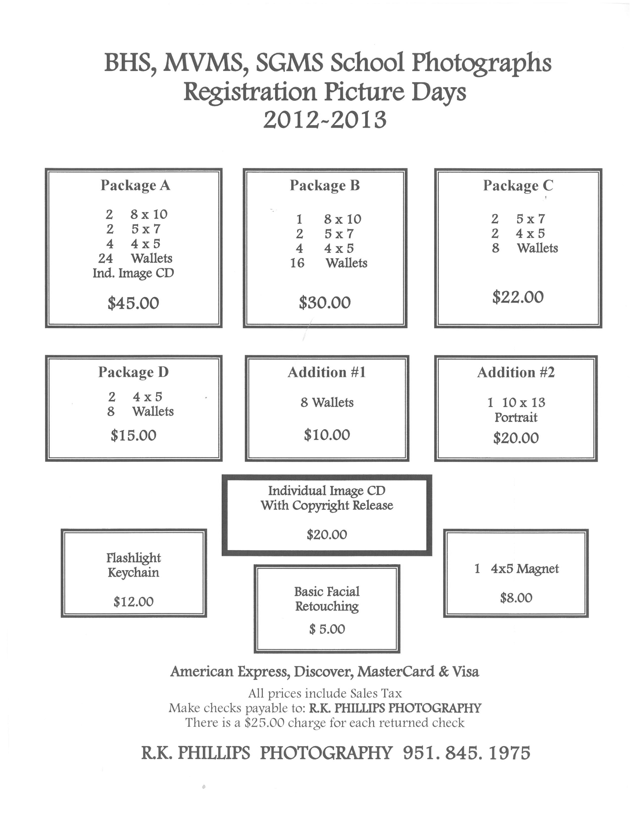
BHS, MVMS, & SCMS School Photographs
Registration Picture Days
2012-2013
1 4X5 magnet
$8.00
$5.00
Basic Facial
Retouching
$12.00
Flashlight
Keychain

- 10X13
Portrait

Addition #2

$20.00
Addition #1

$10.00
8 Wallets

Package D

$15.00
2 4X5
8 Wallets

Package C

$22.00
2 5X7
2 4X5
8 Wallets

Package B

$30.00
1 8X10
2 5X7
4 4X5
16 Wallets

2 8X10
2 5X7
4 4X5
24 Wallets
Ind. Image CD

Package A

$45.00

